

**Department of Mathematics IIT Guwahati**

**Title** - Developing a Database Management system for a coding website (CodeVerse)

**Team**

|  |  |
| --- | --- |
| Name | Roll No. |
| Rahim Khan | 222123040 |
| Ankit Rajput | 222123012 |
| Himanshu Agarwal | 222123025 |

**INTRODUCTION**

**Idea**

CodeVerse is a visionary coding website concept that empowers programmers to write, compile, and execute code in various programming languages, all within a unified online environment. By providing a versatile platform capable of running code in languages like Python, Java, C++, and more, CodeVerse breaks down language barriers, fostering collaboration and learning across the coding community. Users will enjoy the convenience of real-time code execution, immediate feedback, and the ability to compare outputs across languages, enhancing their problem-solving skills and language proficiency.

**Features**

1. Next js and Tailwind CSS is used for frontend
2. Secure Sign in Sign Up using NextAuth
3. A Feature Rich Code Editor Using Code Mirror
4. Execution of codes of 19 different programming languages
5. Leetcode Playground and GeeksforGeeks api’s will be used for code execution
6. Database management using MySQL
7. Users can submit their own coding problem to the websites problem list.

**Frontend**

**Users -** On our website we will have 3 types of users ->

1. **Root user** - It is the root user of the database. It has the access of all the tables exists in the database, and can read, write update, delete anything from the database.
2. **Admin User -** We will have a separate table of users called admin users. Only root user can modify this table. Admin users task is to verify the questions contributed by the other users. He can reject or approve for the same. He can modify the Problem Table (described in later section).
3. **Normal User (user)-** These are the normal users who can sign in, sign up on the website.

**Sign up Page -** Our website will have a sign up page where users can sign up using their email id and password. It will also have the links for forgot password page and sign in page in case user already exist.

When new user will sign up for the first time he will receive the OTP (one time password) on their email id then user will be signed up if he/she provides the correct OTP. In the backend we will maintain the user table for this purpose which is described in the later section.

**Sign In Page -** Our website will have a sign in page where users can sign in using their user id (email) and password. If user id or password doesn’t match to the users exist in the users table error will be thrown for the same. In this page user will also have facility to go for the sign up page and forgot password page. This page will also have the option for sign in for the admin user.

**Forgot Password -** In case user forget their password website will have feature to reset it. To reset the password if user is not signed but user exist in the users table OTP will be sent to the user provided email id then user can reset its password. If user doesn’t exist in the user table and trying to reset the password using email id the he/she will be redirected to the signup page.

**Home Page-** This is the landing page of our website. Where user will have the facility to go to sign in, signup page if user is not already signed in. In the middle page will have a table where coding problems will be listed with their Problem id, Problem title, level of difficulty, indicator whether the current user have solved the particular problem, Problem category, here we will also have the search bar for searching a particular problem. By clicking on the Problem title users can go to the problem page. Which is described in the next section. We will maintain a table for problems. which can only be modified by the admin user. The Problem table is described in the later section.

**Problem Page -** This is the page where users can solve the Problems. This page will have the Problem description ,Problem diagram (if needed) constraints of the problem, Problem category and the test cases and also an option to set the custom test cases.

There will be a section called discussion where different users can discuss about the problem and can provide their ideas for the same.

There will be a code editor on the page where users can write the code in 19 different programming languages which are as follows-

1. C
2. C++
3. Python2
4. Python3
5. Java
6. C#
7. Javascript
8. Ruby
9. Swift
10. Go
11. Scala
12. Kotlin
13. Rust
14. PHP
15. Typescript
16. Racket(x)
17. Erlang
18. Elixir(x)
19. Dart

The code editor will have features such as code highlighting, automatic bracket completion and code completion. For making the code editor JavaScript’s code mirror library will be used.

Now let us discuss about how our code will be executed on the website. Every coding website have the section where we can run our code, without even signing in to the website. We will make use of this facility. We have scrapped the API of these freely available coding grounds, namely we have full details of the two API’s

1. Leetcode Playground API - It is a Free API, and very fast and can run the code of 19 different languages. It uses json schema for communication, although leetcode doesn’t provide this API officially but we can use it for our purpose.
2. GeeksforGeeks Online Code Compiler - like leetcode’s API this is also a hidden API not officially provided by geeksforgeeks but we can use it. it is also a json based API. It supports 15 different programming languages.

On this page we also have the submissions option where users can see their past submission for the current question. For this purpose every user will have a separate table where all of his submitted code will be stored with other useful information like date of submission.

**Admin Page -** The admin user after login will be redirected to this page. Where he can find all the question which are contributed by the users to the websites question bank. He can do approve the question if found errorless then he will update the question in the main question table after that the same problem can be accessed by the other users. If the problem is not correct then admin can revert the problem with appropriate message for the correction to the user who have contributed the problem.

Also, the admin can modify the problems which are in the main question table.

**User Profile Page -** This is the page where user can find the information about their account. Users can modify the Personal details like password, name, Phone number, Profile Picture from here. Since the content like Profile Picture cannot be stored directly in MySQL, we will use Azure blob storage for it and link for the profile picture will be stored in the MySQL database then we can use it in our webpage.

On this page users will have the list of the problems which he has solved in the past. By clicking on the problem title user can view the code he has written.

On this page user also have the list of question with their status he/she has contributed to the website’s question bank.

Here user will also have the link to the Problem set Page which is described in the next section.

**Problem Set Page -** This is the page from where user can contribute their coding question to the website’s question bank. For accessing this page user must be logged in.

On this page one can find the code editor which is described in earlier section where user can run their code for setting the questions.

**Procedure for setting the questions -** For setting the question user should provide a unique title for the question, its category, difficulty level, Detailed description, Diagrams and Images (If necessary) and constraints of the question. Then the user will also provide the testcases. The testcases will be in string format only. Then user will have to write the initial format of the question and how these testcases will be processed internally and output will be produced for all the different languages. User will also provide the answers for the testcases. All these information will be stored in the temporary questions table which is then accessed by the admin user for review the questions as described earlier.

**TOOL AND TECHNOLOGY**

  
Next.js is an open-source JavaScript framework that simplifies the development of web applications. It's built on top of React and offers server-side rendering, automatic code splitting, and a simple routing system.

We have used this as framework for this project.



Tailwind CSS is a utility-first CSS framework that streamlines web development. It provides a set of pre-designed CSS classes that you can apply directly to HTML elements, making it easy to create responsive and customizable user interfaces.

Using Tailwind CSS, we can efficiently design and style our web application while maintaining a clean and maintainable codebase.



NextAuth.js is an authentication library for Next.js applications. It simplifies the process of adding authentication to your web application by providing a set of pre-built authentication flows for various identity providers like Google, Facebook, and others.



CodeMirror is a popular JavaScript library that helps you create a code editor right in your web applications. It's like a special text box that's designed for writing and editing code. within your website or web application. It's commonly used in code-focused websites, online code editors, and integrated development environments (IDEs).



MySQL allows you to store, manage, and retrieve data efficiently using structured query language (SQL). It's widely used in web development to handle tasks such as user authentication, data storage, and content management, among others.

Reason for using MySQL :-

1. **Reliability and Speed:** MySQL is like a really sturdy and fast storage system for your website's information. It can handle lots of people visiting your site at once without slowing down or crashing. This is super important to keep your website running smoothly.
2. **Growing with Your Website:** Think of your website like a tree that keeps getting bigger. As it grows, you might need more space to store stuff. MySQL can expand with your website, so you can always add more space when you need it.
3. **Lots of Help Available:** When you're working on your website, sometimes you might get stuck or need help. MySQL has a big group of people who use it, so you can find lots of guides and tools to help you out. It's kind of like having a big team of friends to assist you with your website.

**DATABASE MANAGEMENT**

We are using MySQL as our database, reasons are already mentioned above. Each page of website contains one or more tables in databases that are connected with each other in appropriate manner.

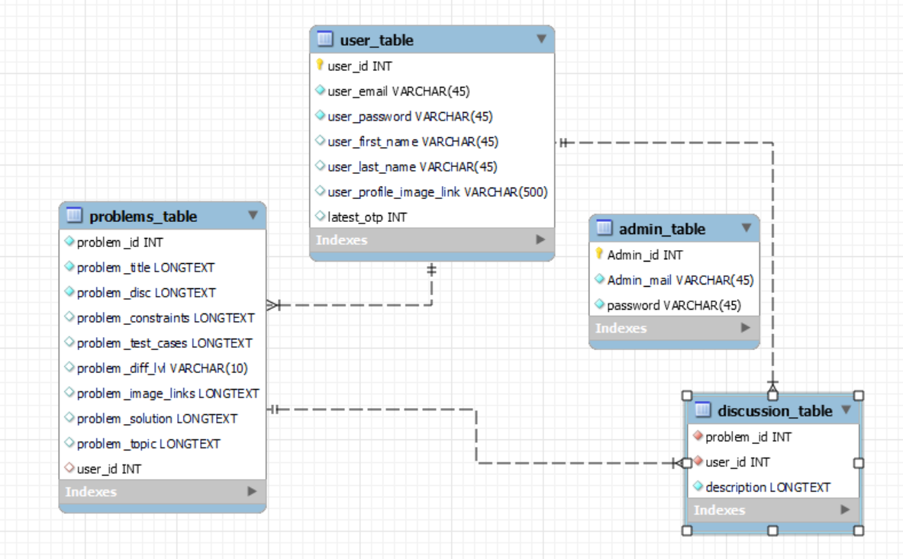

This diagram contains four table, named as problem_table, user_table, admin_table, discussion_table

**problem_table :-** This table has all the columns that are required when a user is going to fill in contribution of problem on the website.

**User_table :-** User table is used to store all the data of the user with unique user id. (this user id is connected to problem table, which specify that which problem is contributed by which user.)

**Admin_table :-** This table contains the details of the admins.

**Discussion_table :-** This table contains the details of the discussion that has been done by users in the particular problem.

**Note :- This is just the visualization of the some tables that the website is going to use, there are many tables that are not specified here.**